**Exploring Energy Dynamics: An In-depth Analysis of Access to Electricity, Electric Power Consumption, CO2 Emissions, and Energy Usage in Nine Countries (2011-2014)**

Name: **Jawad Iqbal**

**Abstract:**

This report explains the complexity of energy dynamics across nine diverse countries—Ghana, Lebanon, Namibia, Pakistan, Philippines, Thailand, Uganda, South Africa, and Zimbabwe—over the period of 2011 to 2014. Using Python-generated visualizations, including bar and line plots, the analysis begins by examining Access to Electricity Data and Electric Power Consumption, shedding light on the disparities and trends within each country. Subsequently, the report explores CO2 Emissions and Energy Usage, providing valuable insights into the environmental aspects of energy consumption. The focus then narrows to a detailed correlation analysis between key economic indicators—GDP, Population, Methane Emission, Tax Revenue, and Energy Use—for Pakistan, South Africa, and Thailand from 2010 to 2014. All coding and data files are meticulously organized in my GitHub repository for accessibility.

**Introduction:**

This report examines the energy dynamics of nine countries (Ghana, Lebanon, Namibia, Pakistan, Philippines, Thailand, Uganda, South Africa, and Zimbabwe) from 2011 to 2014 with a focus on the challenges and opportunities posed by changing energy scenarios. The report offers a thorough understanding of Access to Electricity, Electric Power Consumption, CO2 Emissions, and Energy Usage in these varied nations by utilizing Python-generated visualizations, especially bar and line plots. Aware of the World Bank's enormous amount of data, the author has selected and cleansed datasets to allow for a more in-depth investigation. A thorough analysis of the relationships between the GDP, population, methane emissions, tax revenue, and energy use—specifically for Pakistan, South Africa, and Thailand between 2010 and 2014—adds even more value.

I have also explored different modules such describe, groupby, transpose, skewness, kurtosis etc. inside a python file named ‘Country_To_Year.py’, this file also provide answer to the initial part of the assignment. The python file and data can be found in my GitHub repository.

Link to my GitHub Repository where all data files, python codes and images is below.

<https://github.com/JawadDS/ADS_Assignment2>

**Analysis of Access to Electricity Data:** **Analysis of Electric Power Consumption:**

The access to electricity data displays diverse trends among the selected countries. Ghana and Uganda exhibit substantial access rate increases from 2011 to 2014, signaling notable progress in electrification.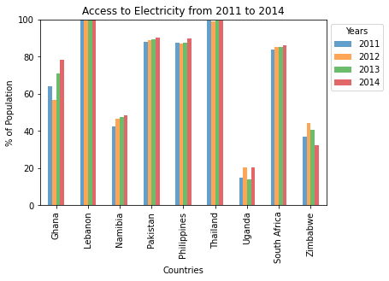 In contrast, Zimbabwe sees a decline, pointing to potential challenges in electricity provision. Lebanon, Thailand, and the Philippines maintain consistently high access rates, indicating stable infrastructure.

**CO2 Emissions:**

The data on CO2 emissions reveals varying trends across countries. South Africa exhibits a consistent increase, possibly due to industrialization, while Ghana and Zimbabwe show fluctuations.

Pakistan and the Philippines demonstrate a steady rise, suggesting sustained economic activity. Lebanon experiences a notable increase in 2014, possibly reflecting changes in energy usage or industrial practices.

**Correlations and Divergences Analysis:**

Analyzing the above data, we found some correlations and divergences across different indicators. For "Access to electricity," there is a positive correlation between increased access

The electric power consumption data reveals varying patterns among countries. Ghana experiences fluctuations, indicating potential changes in energy demand. Lebanon shows a decreasing trend, suggesting possible efficiency improvements.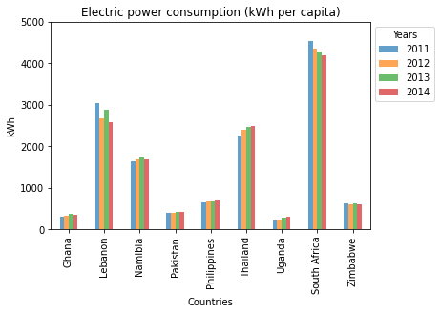

South Africa sees a decline, indicating potential efforts in energy conservation or renewable sources. The Philippines and Thailand exhibit consistent increases, reflecting growing energy demands in developing nations.

**Energy Usage:**

The data on energy use per capita (kg of oil) indicates varying consumption patterns across countries. For instance, South Africa shows a consistently high level of energy use, while Uganda demonstrates a notable increase in 2014.

Lebanon experienced a decline, possibly reflecting changes in energy policies or economic factors.

and decreased electric power consumption, as seen in Ghana, Namibia, and Uganda. Lebanon stands out with consistently high electricity access, but its consumption decreases. For "Electric power consumption," South Africa exhibits a consistent rise, while Zimbabwe shows a decrease. For "CO2 emissions," countries like Pakistan, the Philippines, and Thailand show an upward trend, reflecting increased energy usage. In contrast, Namibia exhibits a modest increase. "Energy usage per capita" varies, with South Africa having consistently high levels, while Uganda experiences a significant increase in 2014.

The correlation heatmap for South Africa (2010-2014) highlights key trends. Notably, there's a negative correlation between GDP and Energy Use, suggesting improved energy efficiency. GDP shows a positive correlation with both Population and Tax Revenue (% of GDP), indicating economic growth aligned with a larger population and increased tax contributions. Further exploration is needed for the relationships between GDP and Methane Emissions, as well as Energy Use and Methane Emissions. The positive correlation between GDP and Tax Revenue (% of GDP) implies that economic expansion is associated with higher tax contributions as a percentage of GDP.

The correlation analysis for Thailand's economic indicators from 2010 to 2014 reveals several key insights. There is a noteworthy positive correlation between GDP and Tax Revenue (% of GDP), suggesting that as the economy grows, tax contributions as a percentage of GDP tend to increase. Additionally, the heatmap indicates a potential negative correlation between GDP and Energy Use, signifying efforts towards enhanced energy efficiency in economic activities. The relationship between GDP and Methane Emissions, as well as Energy Use and Methane Emissions, requires further exploration for a comprehensive understanding. The Tax Revenue (% of GDP) exhibits fluctuations without a clear trend over the years.

The correlation analysis for Pakistan's economic indicators from 2010 to 2014 reveals several noteworthy trends. There is a consistent positive correlation between GDP and Tax Revenue (% of GDP), indicating that as the economy grows, tax contributions as a percentage of GDP tend to increase. Additionally, the heatmap highlights a potential negative correlation between GDP and Energy Use, reflecting efforts towards greater energy efficiency in economic activities. The correlation between GDP and Methane Emissions, as well as Energy Use and Methane Emissions, requires further exploration. The Tax Revenue (% of GDP) shows an upward trend over the years, suggesting a positive association with economic growth.

